BELOW IS A SAMPLE OF HOW THE FLYER SHOULD LOOK
– SEE NEXT PAGE AND DELETE THIS ONCE READY TO DESIGN YOUR OWN!

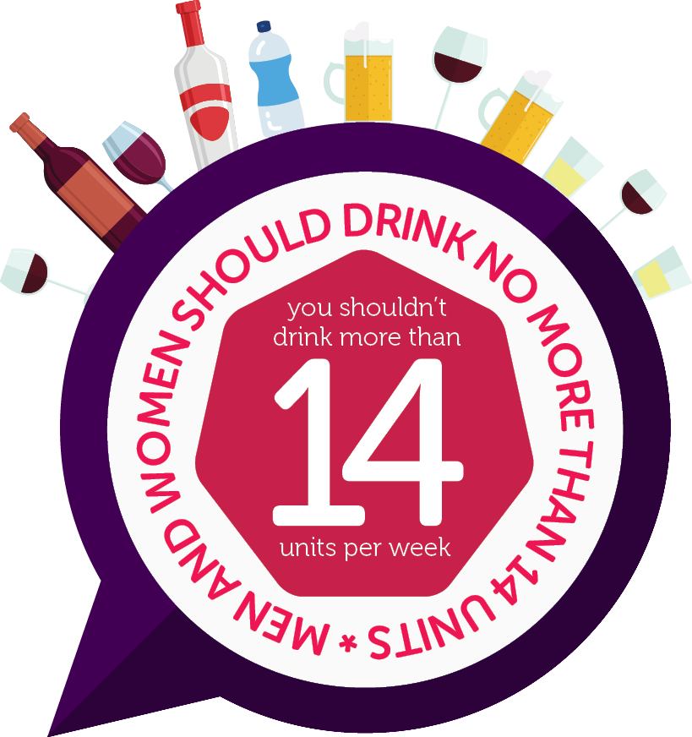
Come and find out more…
Come and find out more…
Come and find out more…
Come and find out more…
HEAD
This is a subheadline

Call to action here

